SQL DATABASE COMMANDS

DDL | DML | DCL | TCL

BANK MANAGEMENT SYSTEM
Practical Execution & Results

SECTION 1: DDL (DATA DEFINITION LANGUAGE)
Commands: CREATE, ALTER, DROP, TRUNCATE, RENAME

Execution Screenshot 1: CREATE TABLE & ALTER Commands
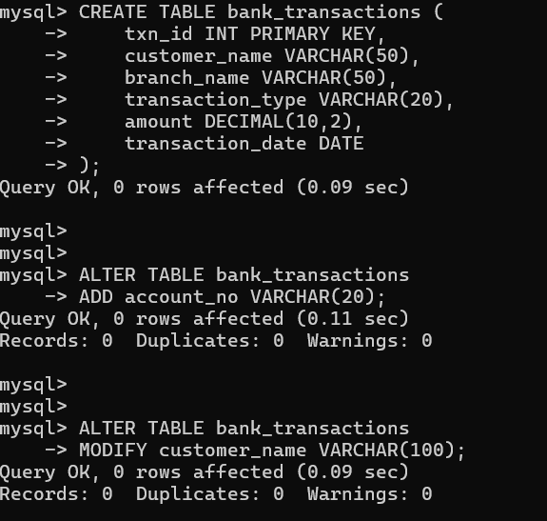
Results: CREATE TABLE bank_transactions successfully created. ALTER TABLE commands ADD account_no and MODIFY customer_name executed without errors.

Execution Screenshot 2: RENAME & TRUNCATE Commands
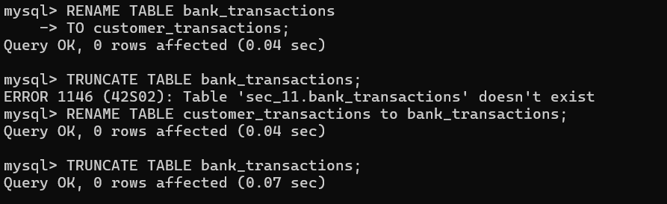
Results: RENAME TABLE bank_transactions TO customer_transactions executed. TRUNCATE TABLE command successfully removed all rows while preserving table structure.

Execution Screenshot 3: ALTER DROP & INSERT Commands
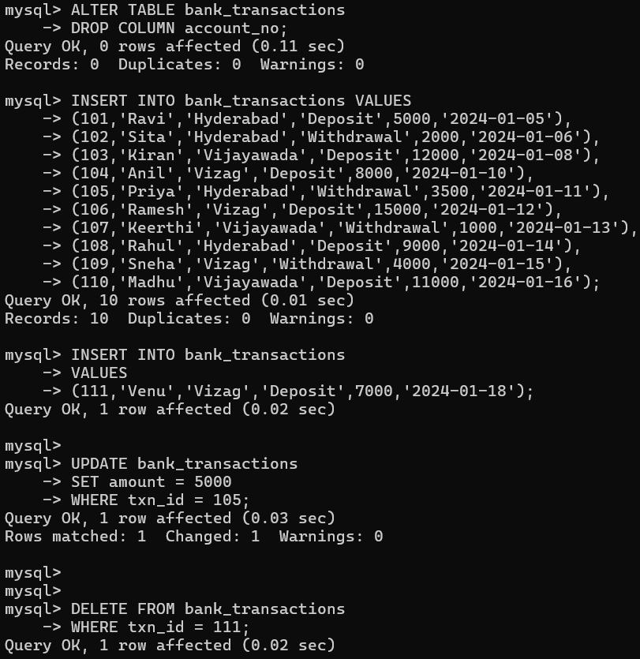
Results: ALTER TABLE DROP COLUMN account_no executed. 10 rows of sample transaction data successfully inserted into the bank_transactions table.

SECTION 2: DML (DATA MANIPULATION LANGUAGE)
Commands: INSERT, UPDATE, DELETE, SELECT

Execution Screenshot 4: SELECT Queries (All Data, WHERE Clause, ORDER BY)
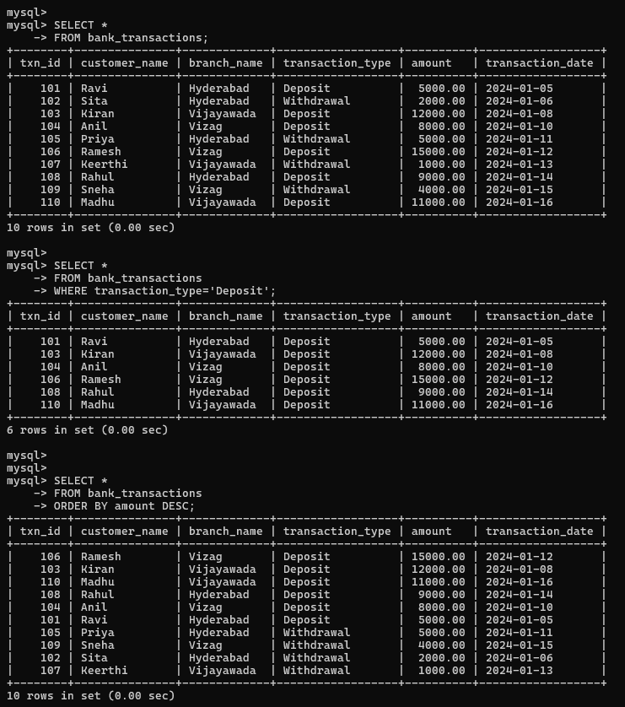
Results: SELECT * FROM bank_transactions returned 10 rows. SELECT with WHERE transaction_type="Deposit" returned 6 deposit records. SELECT with ORDER BY amount DESC sorted all transactions from highest to lowest amount.

SECTION 3: DCL (DATA CONTROL LANGUAGE)
Commands: GRANT, REVOKE

Execution Screenshot 5: CREATE USER, GRANT & REVOKE Privileges
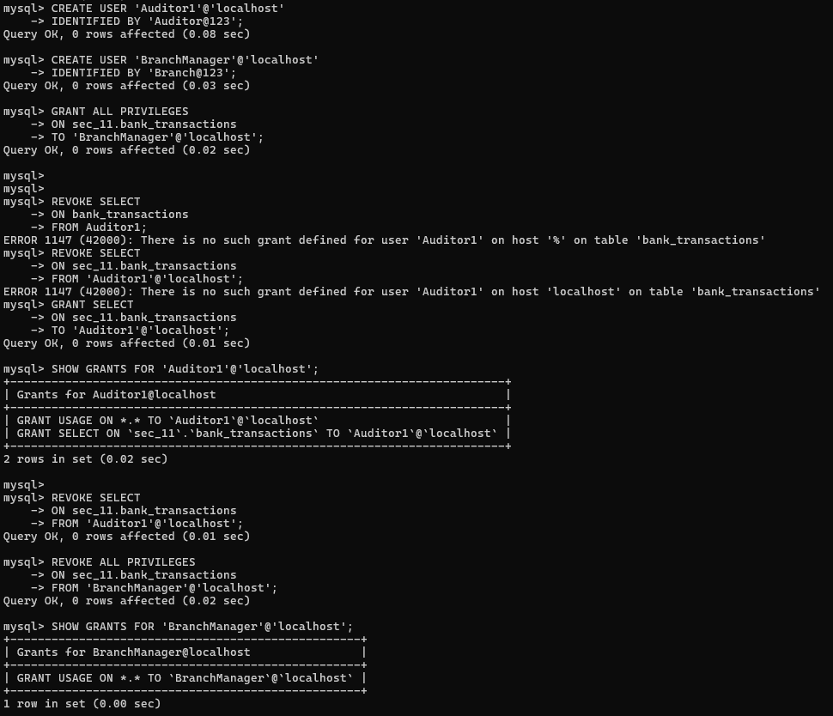
Results: Created two users (Auditor1 and BranchManager). GRANT ALL PRIVILEGES executed for BranchManager. REVOKE SELECT removed permissions from Auditor1. SHOW GRANTS commands displayed current user privileges.

SECTION 4: TCL (TRANSACTION CONTROL LANGUAGE)
Commands: COMMIT, SAVEPOINT, ROLLBACK

Execution Screenshot 6: Transaction Control - SAVEPOINT, ROLLBACK & COMMIT
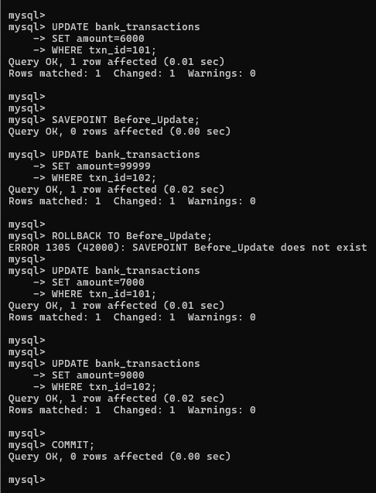
Results: UPDATE command modified transaction amounts. SAVEPOINT Before_Update created a checkpoint. Subsequent ROLLBACK TO Before_Update reverted changes to the savepoint. COMMIT finalized all confirmed transactions permanently.

COMMAND SUMMARY
Category | Commands | Purpose
DDL | CREATE, ALTER, DROP, TRUNCATE, RENAME | Define database structures and schemas
DML | INSERT, UPDATE, DELETE, SELECT | Manipulate and retrieve data
DCL | GRANT, REVOKE | Control user access and permissions
TCL | COMMIT, SAVEPOINT, ROLLBACK | Manage transaction consistency

All SQL commands executed successfully on the MySQL Database Management System. The bank_transactions table was created, populated with sample data, queried with various SELECT statements, modified using UPDATE commands, and access control was demonstrated through GRANT and REVOKE operations.

